File being refreshed shows update date/time of 10/23/18 7:15 am.
Just to confirm that the update actually happened to the two sheets populated by workflow A, I manually open and close Excel file to check, and both are showing 10/23/18 as the last updated date.
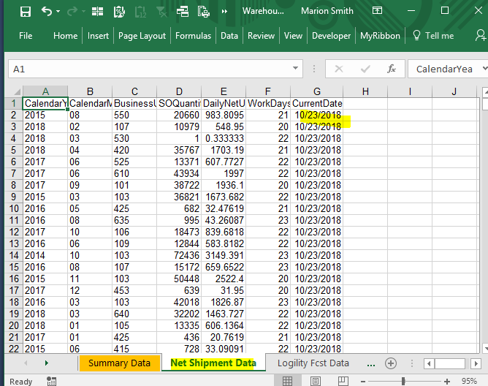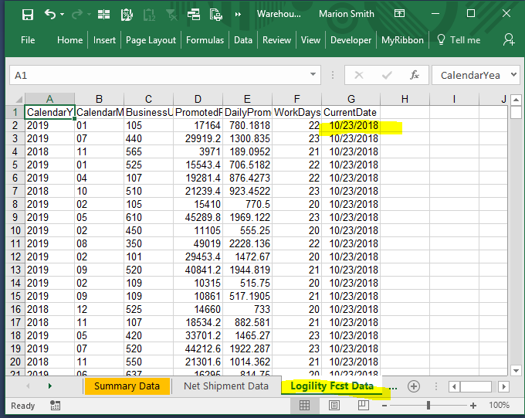
Then when I run the workflow at 7:59 am on 10/23, the values returned are from 10/22. {Input tool with annotation ‘(actual)’ points to file referenced above, but not directly to the worksheets shown above, due to business logic, I need to combine the data on the sheet workflow B is pointed at.}
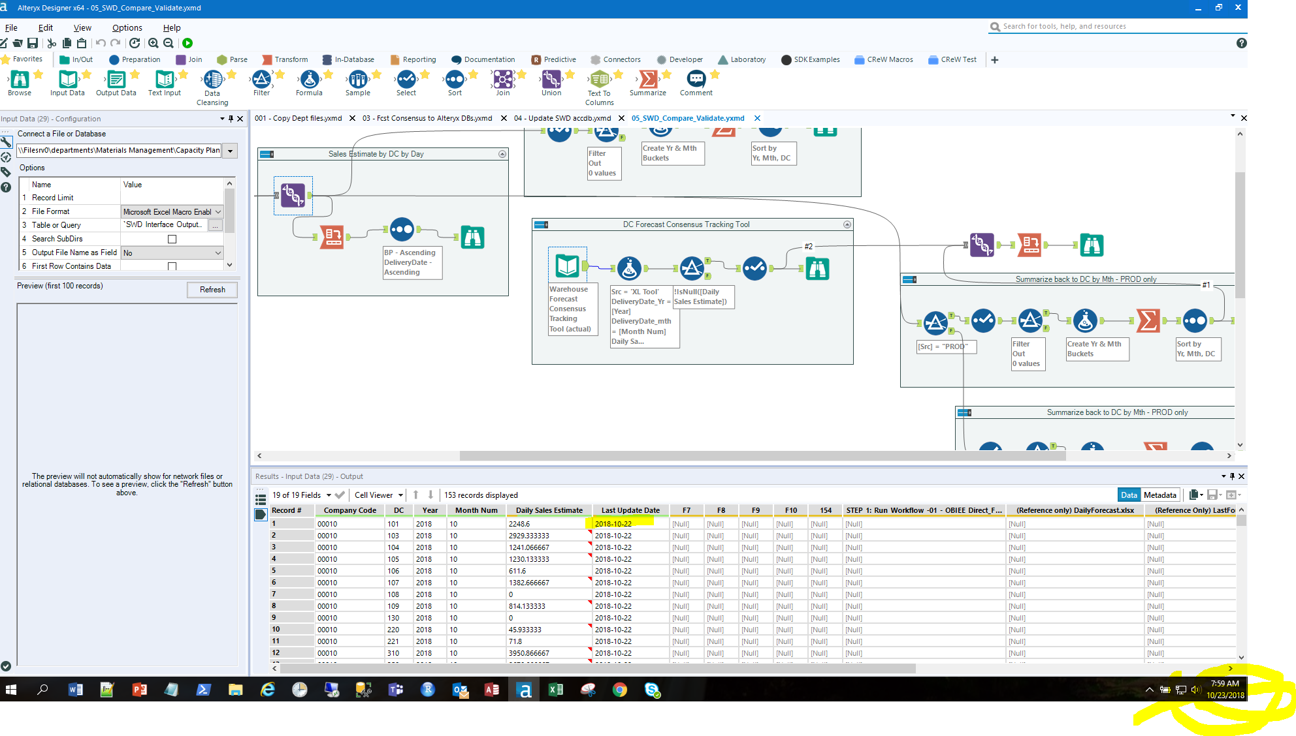
After running the workflow, Alteryx is showing 10/22. The Excel file is showing 10/23 {a}. Note: the formula on the sheet workflow B is referring to points to the sheets populated earlier in the day by workflow A.
a)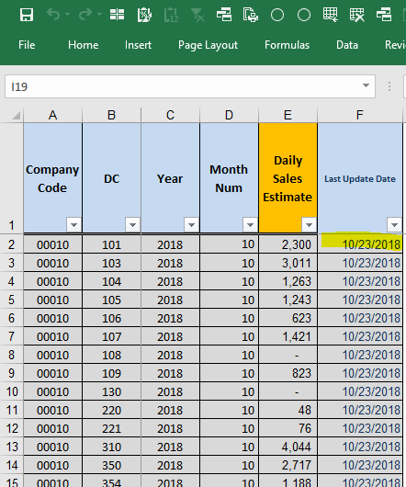 b) 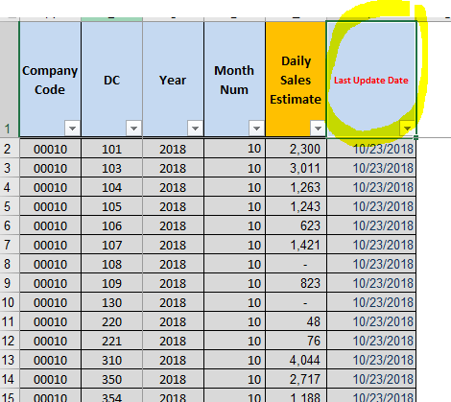
I then make one small arbitrary change {b} (font color in cell F1 to red) and save and close the file.
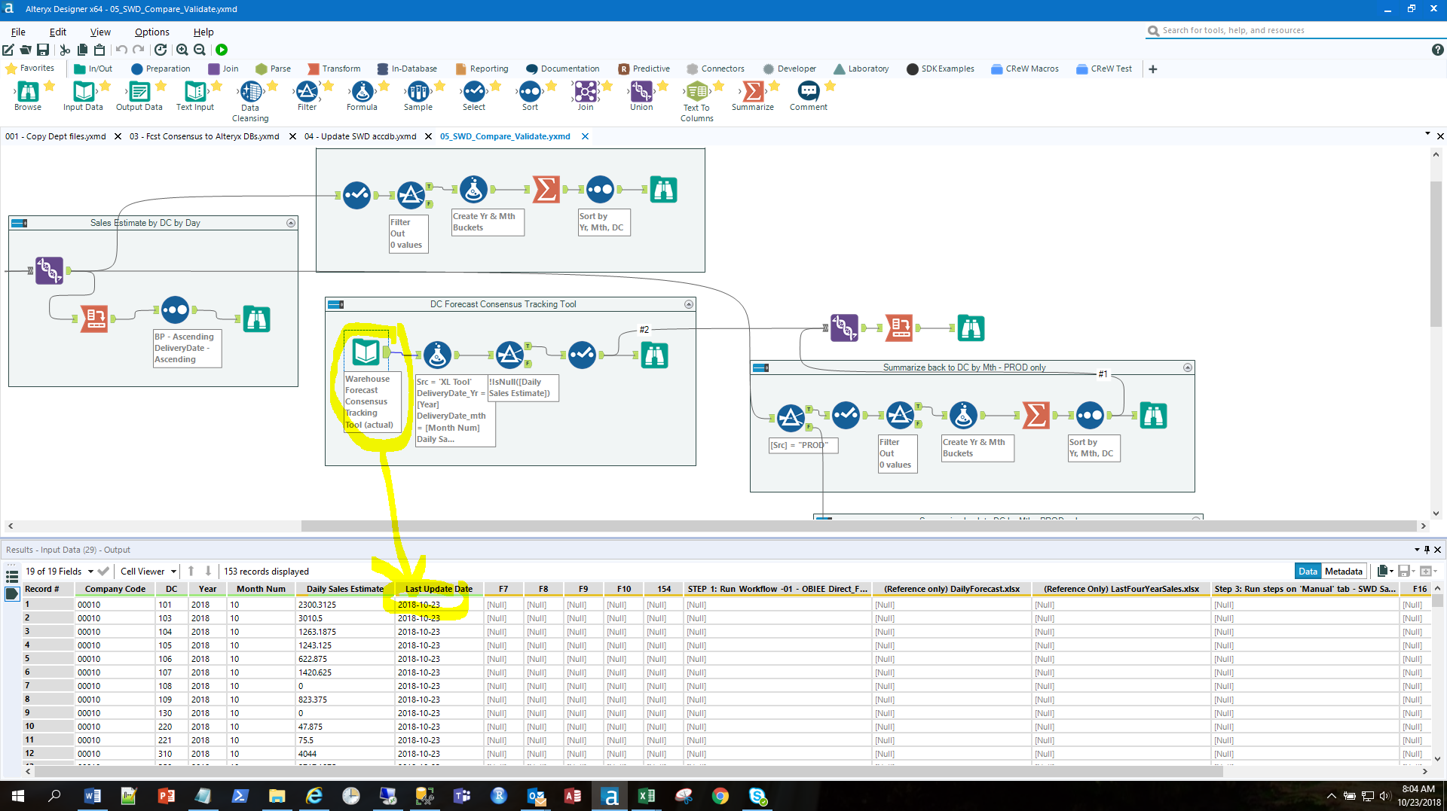 Now when I run the workflow the correct values come back.

