Created POSTGRESQL : ODBC Connection (9.03.04)
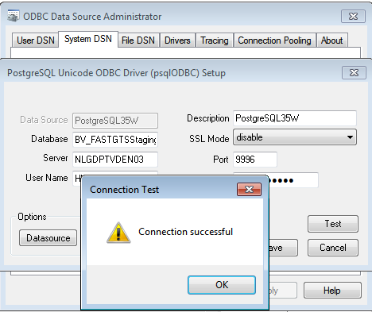

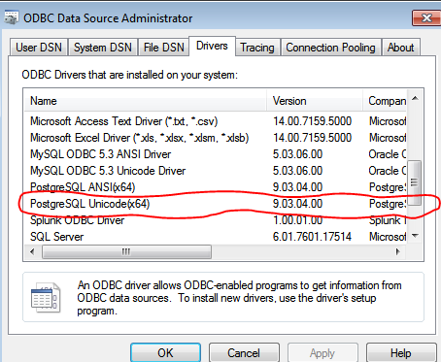
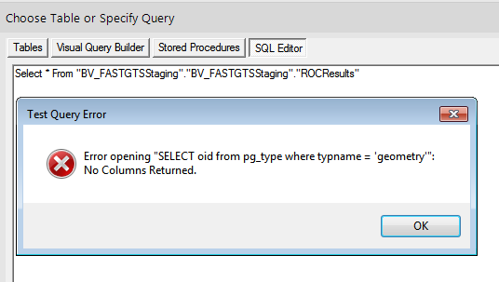
Tried connecting to Different tables where there are no GEO attributes in the table. I was able to connect and retrieve the tables however unable to retrieve the data. This seems to be a Bug in the new version.

