Input –
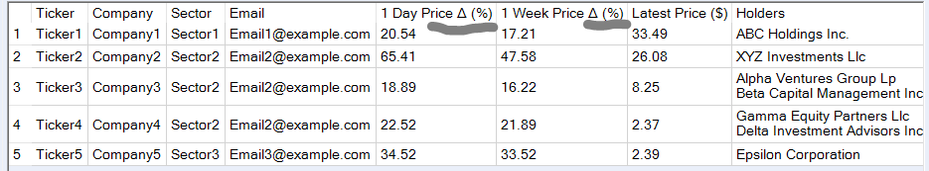

Workflow –
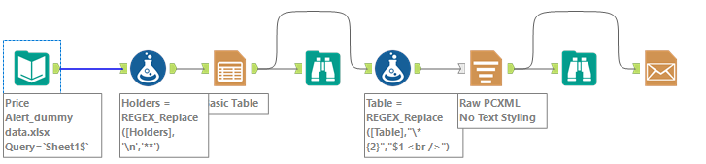
Output table -
