Corrupted output not sure about the error 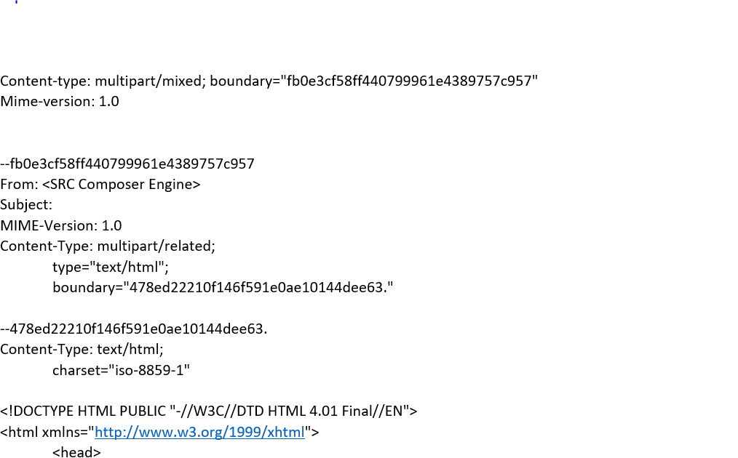

Output which has generated and expected has come after adding few email ids
